Title

Oracle Troubleshooting Sop

Prepared By
Helpdesk

Date: Monday, July 19, 2010

Version 1.0

Document History

Date | Author | Revision | Description
26-10-2010 | MN Kalyan | 1.0 | Document Creation

Approved By: | Tata Business Support Services Limited
Rama Krishna TV | 1.0 | Manager-Technology

Distribution List
Name | Department | Company | Rights
MN Kalyan | Technology | Tata BSS | Review & Comment
Ramakrishna TV | Technology | Tata BSS | Modify
Ali Hyder | Technology | Tata BSS | Review & Approve

Security Classification: Tata BSS Restricted.

Procedure:

IF ORACLE IS TOO SLOW…

1.Open my computer

2.click on c:

3.Open documents and settings

4.Select the user profile and open it

5.delete jar cache folder contents.

And enable activex controls and plug-ins
Open internetnet explorer
• click on tools
• select internet options
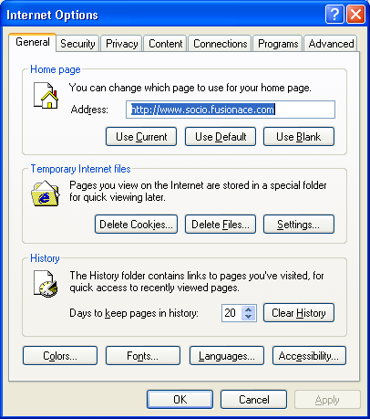
• select security tab
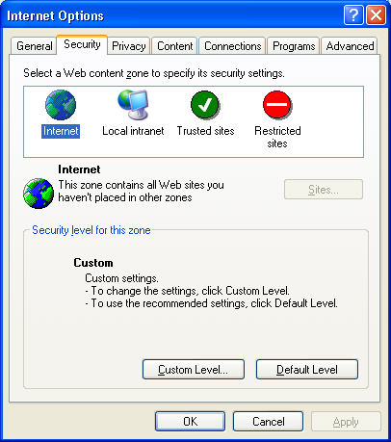
• Click on custom level
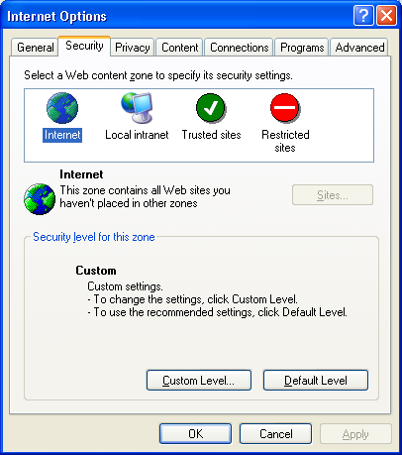
• Enable all security settings activex controls
• Select on local internet
• Click on custom level
• Enable all activex controls and plug ins

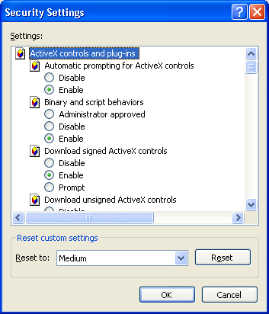

• Click on ok and save the settings
• Then it will work fine
Oracle unable to open

1 Check first host entire if there are not
Go→start→click→run→drivers\
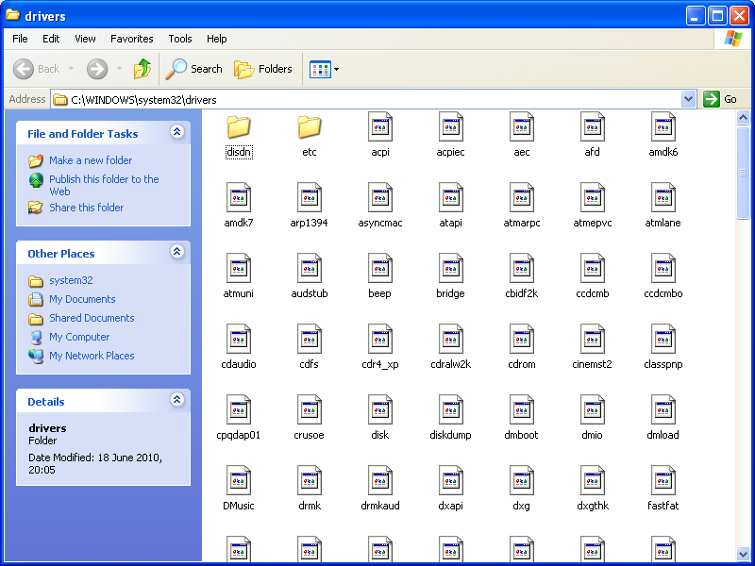
Etc→host
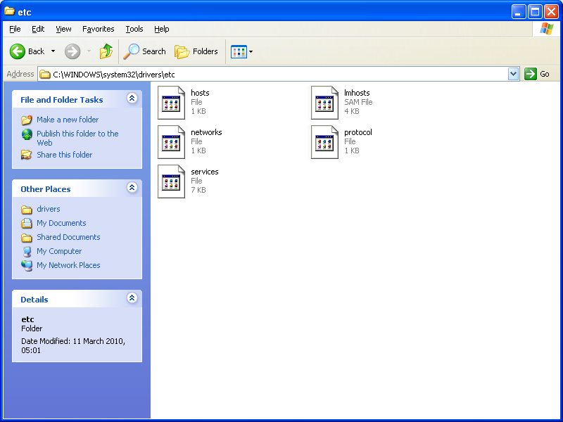

Open with notepad
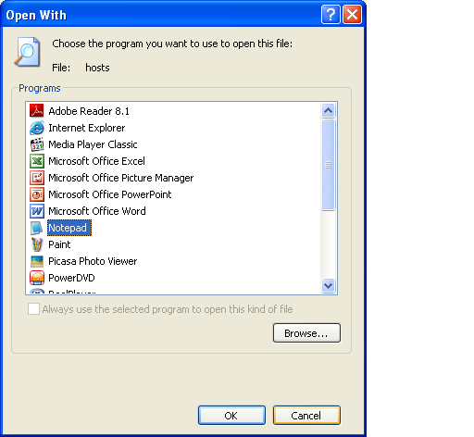

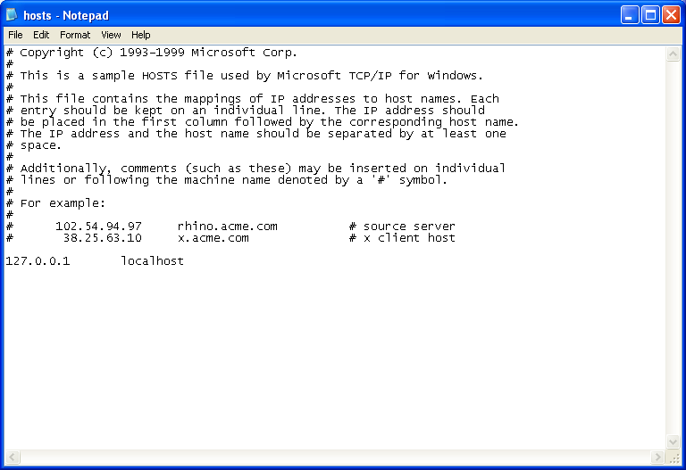

If duplicate host name entire are their with same name, so remove that duplicate entire

2 right click on IE

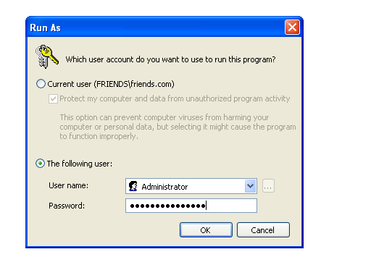
Admin windows will open and copy the link to admin window and press enter
When we copy CRM link in admin window it will install active X control path
It will work

3 check the C:\drive space
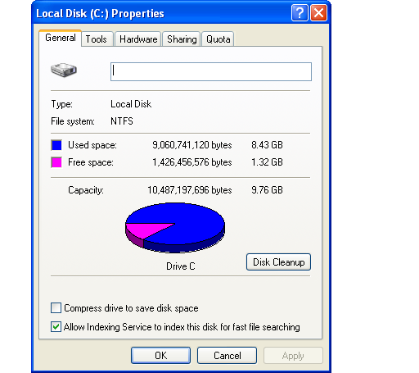

Whether C:\drive is full delete unwanted files
Go C:\drive\windows\in windows #uninstall# files will create, so delete that files and keep the cleanup it will delete temp files from users profiles
To open oracle link minimum space is required

- In user profiles jar cache will create so delete that files and check
Go to the control panel and uninstall the jinstrator and open CRM link in admin window and check it will install the patch and check.

